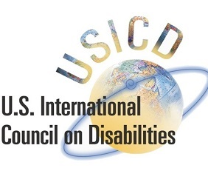

UNITED STATES INTERNATIONAL COUNCIL ON DISABILITIES
Application for Appointment to the Board of Directors
Email application to info@usicd.org by Sunday, October 25th at 11:59PM EST
First Name: _________________________ Last Name: _______________________________
Address: _____________________________________________________________________
_____________________________________________________________________________
City: _______________________________ State: _________ Zip Code: __________________
Mobile Phone: ______________________ Business Phone: ___________________________
Email Address(es):
Business email: _______________________________________________________________
Home email: _________________________________________________________________
Occupation: __________________________________________________________________
Linked In Profile (Provide URL):___________________________________________________
Twitter Handle: _______________________________________________________________
Describe your education, experience and skills that will add value to the Board and to USICD:

On what boards have you previously served (please list):

Do you currently serve on other boards? If yes, please list:

In addition to board and committee meetings, how many hours per month are you will serve in support of the organization?

Are you a person with a disability (circle one): Yes / No

Can you make a financial commitment of $1,000 to $5,000 or more to support USICD?

What is your interest in USICD?

